ARE YOU STRUGGLING TO COOK A HOT MEAL?

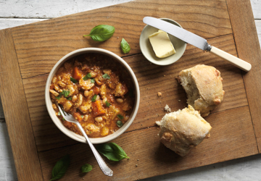
Sometimes when you are going through a hard patch healthwise, or you have hit that time when making a hot meal, or getting the shopping in has become a bit of a struggle, there is a highly recommended service for you. Apetito, in partnership with Warwickshire County Council, can deliver a hot meal directly to your door everyday of the year for a reasonable price, and they also offer a well being check for you, and your family’s reassurance.
- No contracts and no delivery costs. Can be short term during illness, or hospital recovery.
- Hot meal delivered between 11.30am and 2pm.
- Daily safe and wellbeing checks by DBS staff. If they cannot get a reply from you, they will contact family for example. They can use a keysafe system if you cannot get to the door.
- Tastes and dietary needs (including soft and pureed meals) catered for in a good menu range.
- £4.25 for a two course meal, can be extended to have soup as well (extra £1), and a tea time pack of a sandwich, fruit and cake (£4).
Simple sign up by you or a family member—call 0800 090 3625 and they will talk you through the sign up process, payment method and delivery process. You can cancel at any time by phoning by 10am on the day of delivery.
For full details and sample menus visit ;
https://www.apetito.co.uk/hot-meals-delivery-service/
https://www.warwickshire.gov.uk/mealsservice

