EXERCISE REFERRAL FROM YOUR GP AT THE DIAMOND JUBILEE FITNESS CENTRE, RUGBY.

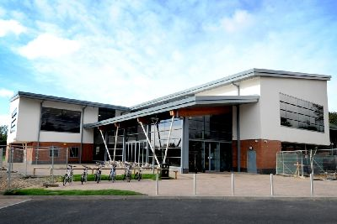
Exercise is known to be one of the most effective ways of combatting Parkinson-both the physical effects and it’s progression. If you can maintain a good level of cardiac fitness, muscle strength and improve your co-ordination, your body is better prepared to cope with the changes that are happening. The effects of exercise on your mental well being are widely documented. Exercise groups are a great way of increasing your social network as well, at a time when you may feel isolated perhaps from a work environment or your normal friendship circle due to a change in lifestyle.
We offer a Nordic walking and seated exercise groups, but you can also go to your GP and ask for a referral to the Queens Diamond Jubilee Sports Centre, who run several classes that may be suitable for you. Of course, not all these will be suitable for you due to other health needs, and your GP practise may not be able to offer a suitable one depending on cost restrictions and individual GP practise priorities, but it is worth asking and exploring at the centre. The contact is
https://www.better.org.uk/leisure-centre/rugby/the-queens-diamond-jubilee-centre
telephone number 01788 565369
You can phone them to discuss what sort of things that they offer which could be helpful to you, and then approach your GP to discuss it further with them. These classes obviously change from time to time depending on staff and numbers wanting them, so it is best to ring and ask, or pop in and see them.

